Material Name: KF301 - 2P3P4P Terminal Block PCB Terminal 5.08MM Terminal Post Splittable High Current Plug-in

The spring piece is made of phosphor bronze plated with nickel, and the stainless steel screws are of M2.5 size.

Product Parameter：

|  |  |  |
| --- | --- | --- |
| **Attribute** | **Parameter value** |  |
| Product Catalogue | Screw-type terminal block |  |
| Spacing | 5mm |  |
| Number of Rows | 1 |  |
| Number of Pins per Row | 2 |  |
| Installation method | Staight needle |  |
| Rated current | 15A |  |
| Rated voltage | 300V |  |
| Wire gauge - AWG | 12~24 |  |
| Wire gauge - mm² | - |  |
| Operating temperature range | -40℃~+105℃ |  |
| Color | Blue |  |

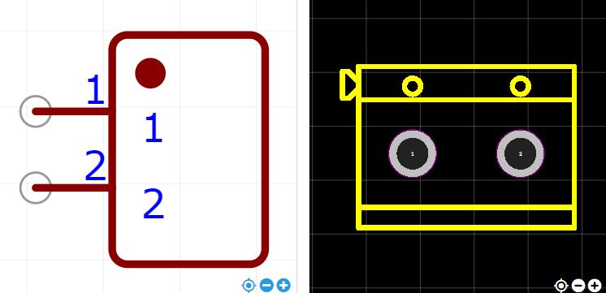

<https://item.szlcsc.com/375601.html>